

Year 8 Science 2023

**Biology 1 Test: Cells**

**SECTION 1: MULTIPLE CHOICE** (1 mark each)

Circle your answer on the multiple choice answer sheet.

*The first two questions are about the following diagram, which shows onion cells under a microscope.*

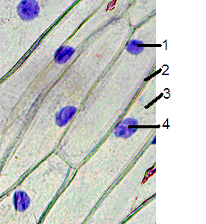

1. What is the **name** of the structure that is **labelled 1** on the diagram above?
   1. nucleus
   2. membrane
   3. golgi
   4. mitochondria
2. The **cytoplasm** is labelled
   1. 1
   2. 2
   3. 3
   4. 4
3. Which of the following is found in an **animal cell**?
   1. cell membrane
   2. cell wall
   3. chloroplasts
   4. large vacuoles
4. Which **part of a cell** controls cell functions and contains DNA, the “recipe” for all cell parts and products?
   1. cell membrane
   2. nucleus
   3. cytoplasm
   4. vacuole
5. The function of **chloroplasts** is
   1. making food by the process of photosynthesis.
   2. producing energy by the process of respiration.
   3. protecting the cell from damage by chemicals or germs.
   4. making the cell turn green.
6. The function of the **cell wall** and **vacuoles** is
   1. the cell wall stores water that keeps the cell rigid, while the vacuole drains this water away.
   2. the vacuole fills up with water, pushing the cell contents against its wall, keeping it rigid.
   3. the cell wall shrinks to pump water into the vacuole.
   4. the cell wall is thin and weak, but the vacuole is tough and rigid..
7. Which of the following is **not** a process that animal cells undergo?
   1. respiration
   2. diffusion
   3. division
   4. photosynthesis
8. How do we **grow**?
   1. Our cells get bigger.
   2. We get less cells.
   3. Cells divide in two to make new cells.
   4. Each cell produces lots of smaller cells, which slowly get bigger.
9. Our cells’ **energy source** is
   1. glucose.
   2. sucrose.
   3. oxygen.
   4. sunlight.
10. Plants can photosynthesise **without**
    1. sunlight.
    2. oxygen.
    3. carbon dioxide.
    4. water.

**SEMESTER ONE 2023**

**Biology Science Test Year 8:**

**ANSWER BOOKLET**

**NAME:**

**FORM:** **DATE:**

Multiple Choice Short Answer Total

**/10**

**/30**

**/20**

**SECTION ONE:** Multiple choice answers

Cross (X) through the correct answer.

|  |  |  |  |  |
| --- | --- | --- | --- | --- |
| **1** | a | b | c | d |
| **2** | a | b | c | d |
| **3** | a | b | c | d |
| **4** | a | b | c | d |
| **5** | a | b | c | d |
| **6** | a | b | c | d |
| **7** | a | b | c | d |
| **8** | a | b | c | d |
| **9** | a | b | c | d |
| **10** | a | b | c | d |

**SECTION 2: WRITTEN**

**Write your answers on the lined paper provided. Total 20 marks**

1. Write the **name** of the cell parts labelled A to F on the diagrams below (6)

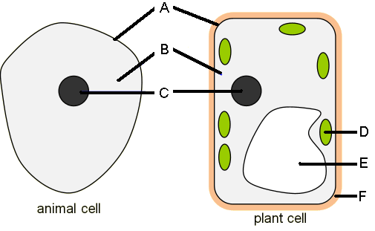

A _______________________ B ______________________

C _______________________ D ______________________

E _______________________ F ______________________

1. Write the word equation for respiration (1)

_______________________________________________________________

1. Write the word equation for photosynthesis (1)

_______________________________________________________________

1. Name the cell part that carries out each function (5)
2. The outer boundary of the cell, lets some things into and out of the cell

_______________________________

1. The tough, rigid structure that surrounds a plant cell

________________________________

1. Makes energy for the cell by respiration

________________________________

1. Where proteins are made

_______________________________

1. A collection of membranes that transport materials around the inside of the cell

_______________________________

1. Complete the table below by writing the **number** that matches each **part name.** (7)

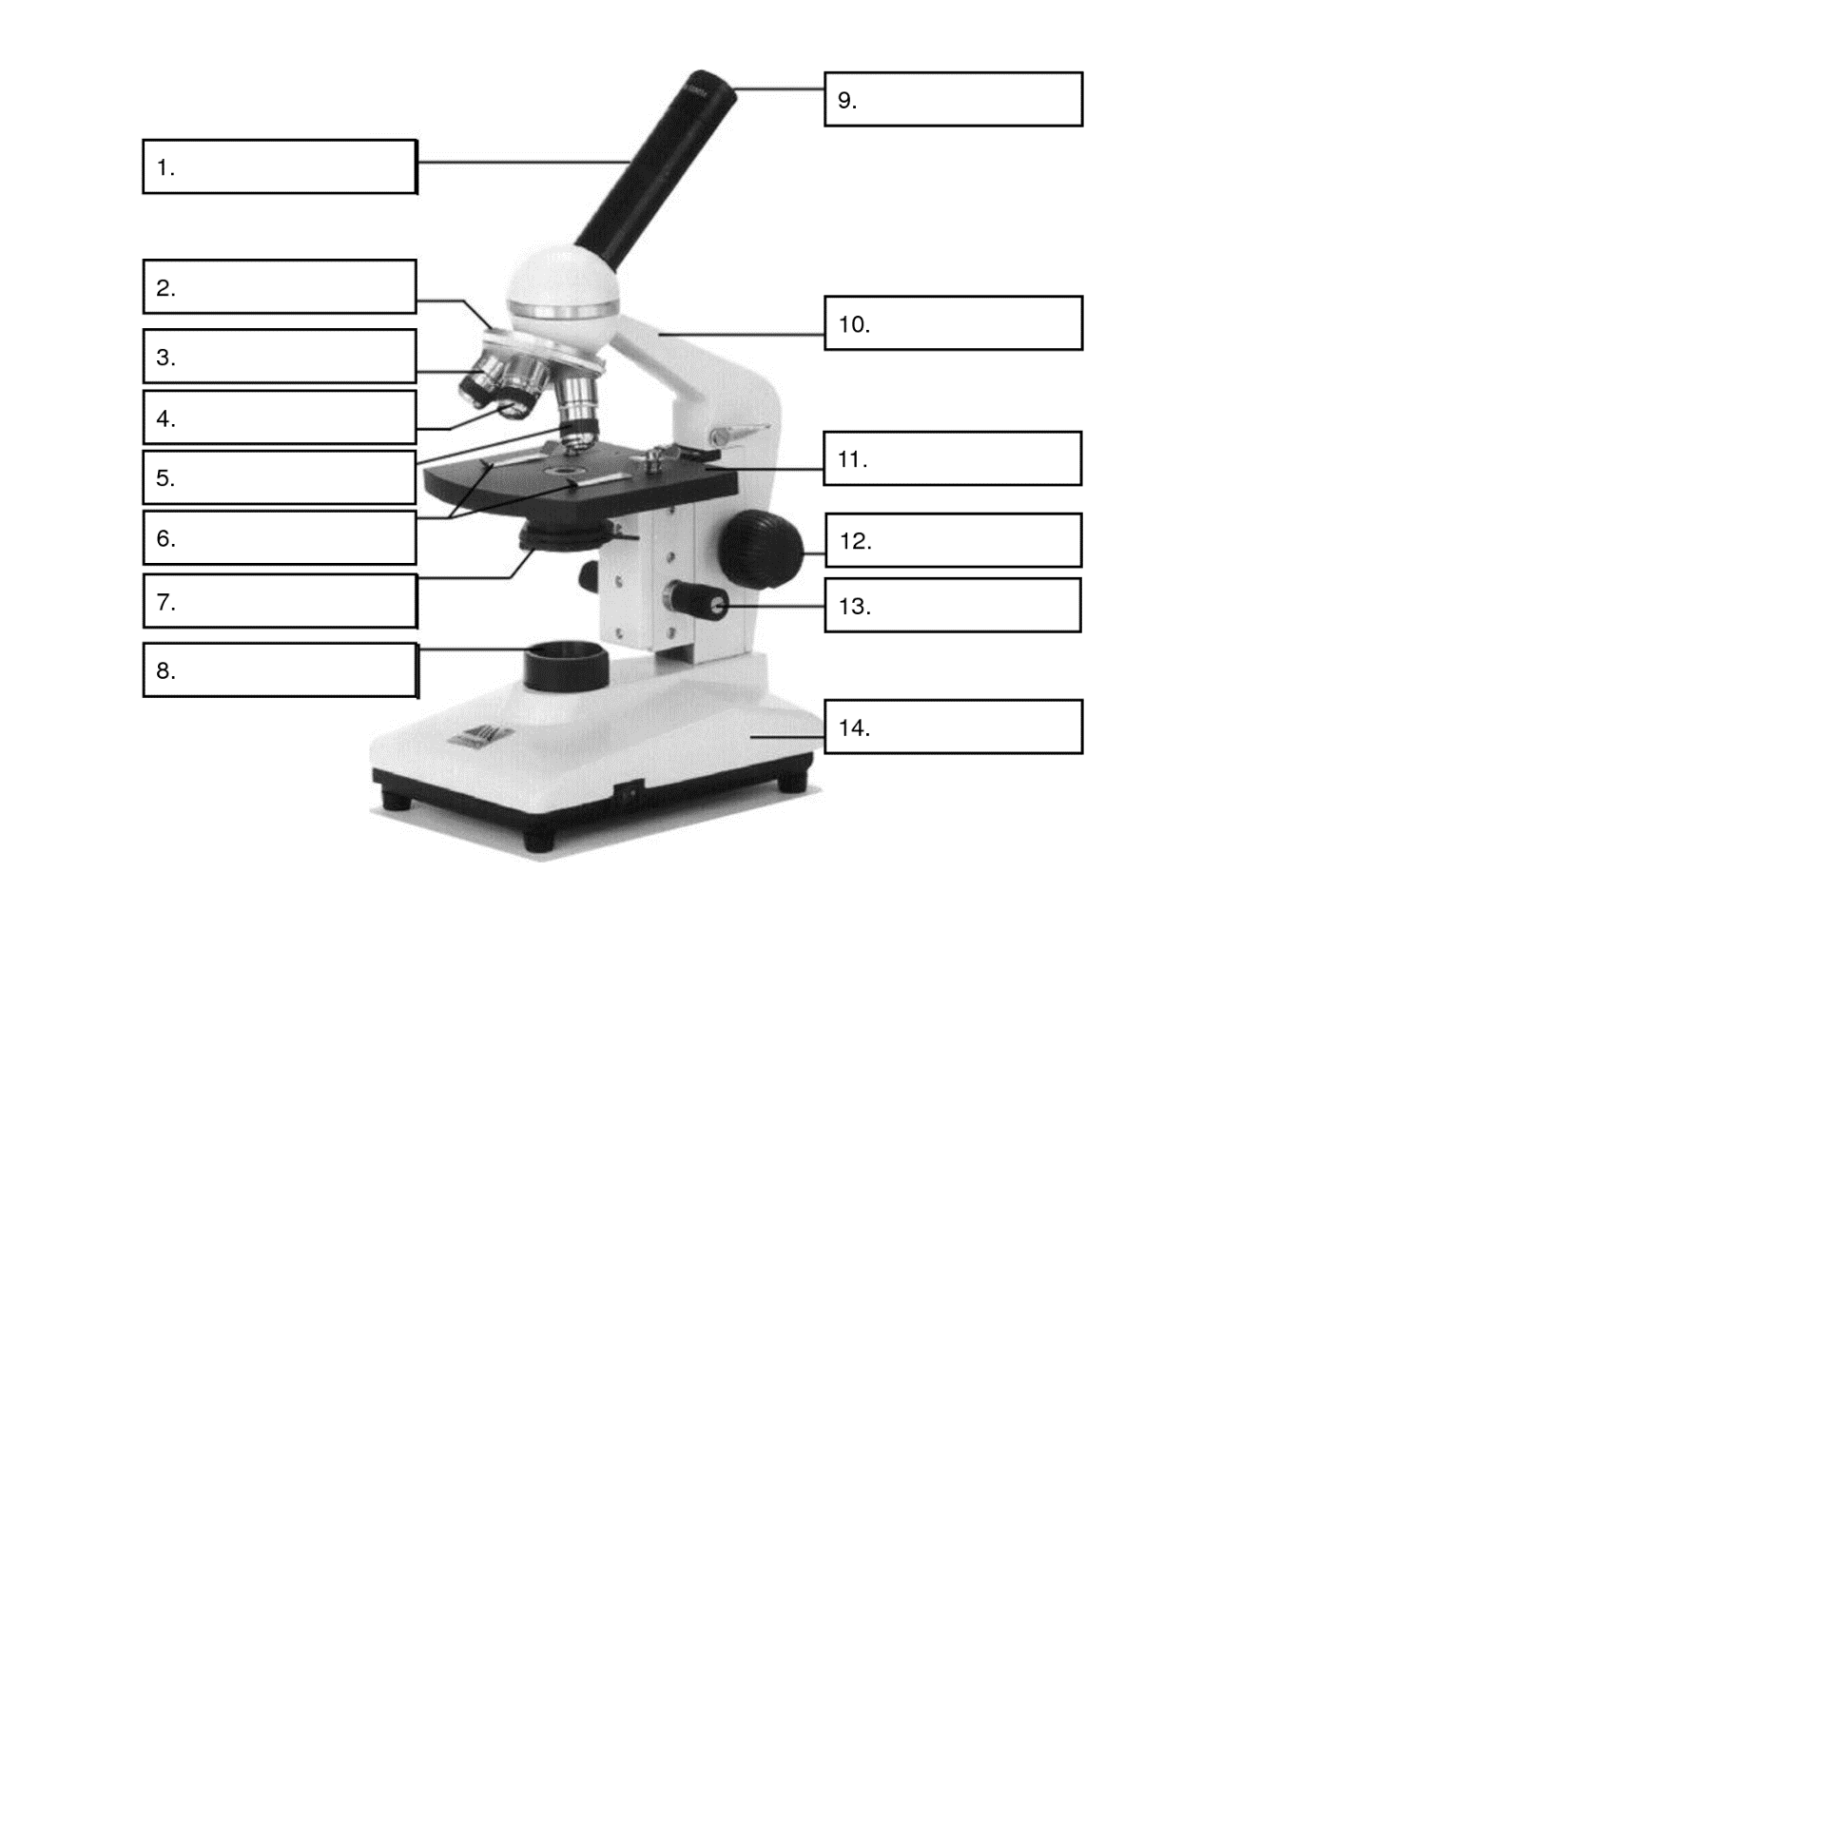

|  |  |  |
| --- | --- | --- |
| **Letter** | **Part Name** | **Number** |
| A | Light |  |
| B | Stage Clips |  |
| C | Eye Piece |  |
| D | Body Tube |  |
| E | Arm |  |
| F | Coarse Focus |  |
| G | Nose Piece |  |
| H | Iris diaphragm |  |
| I | Lower Power |  |
| J | Stage |  |
| K | Fine Focus |  |
| L | High Power |  |
| M | Base |  |
| N | Medium Power |  |